Contents
Home. 2
Welcome to IIFR. 2
What is IIFR. 2
Three Pathways to Transform Your Impact 3
Programmes Designed for Academic and Professional Excellence. 3
Insights from IIFR. 4
Let's Build the Future of Education, Together. 5
ABOUT US. 6
About Us. 6
Our Vision. 7
Leadership & Governance. 8
Strategic Partners. 10
Let's Build the Future of Education, Together. 11
Programmes. 12
Programmes for Real-World Impact 12
Educator Certification Programme (ECP) 12
Executive Fellow in Management (EFM) 12
Academic Leadership Programme (ALP) 12
Research & Faculty Development Programme. 12
Custom Executive & Institutional Programmes. 13
Why Choose IIFR Programmes. 13
Who These Programmes Are For 14
Research. 15
Faculty & Research for Real-World Impact 15
Our Faculty. 16
Research that Solves Real Problems. 17
Collaborate With IIFR. 17

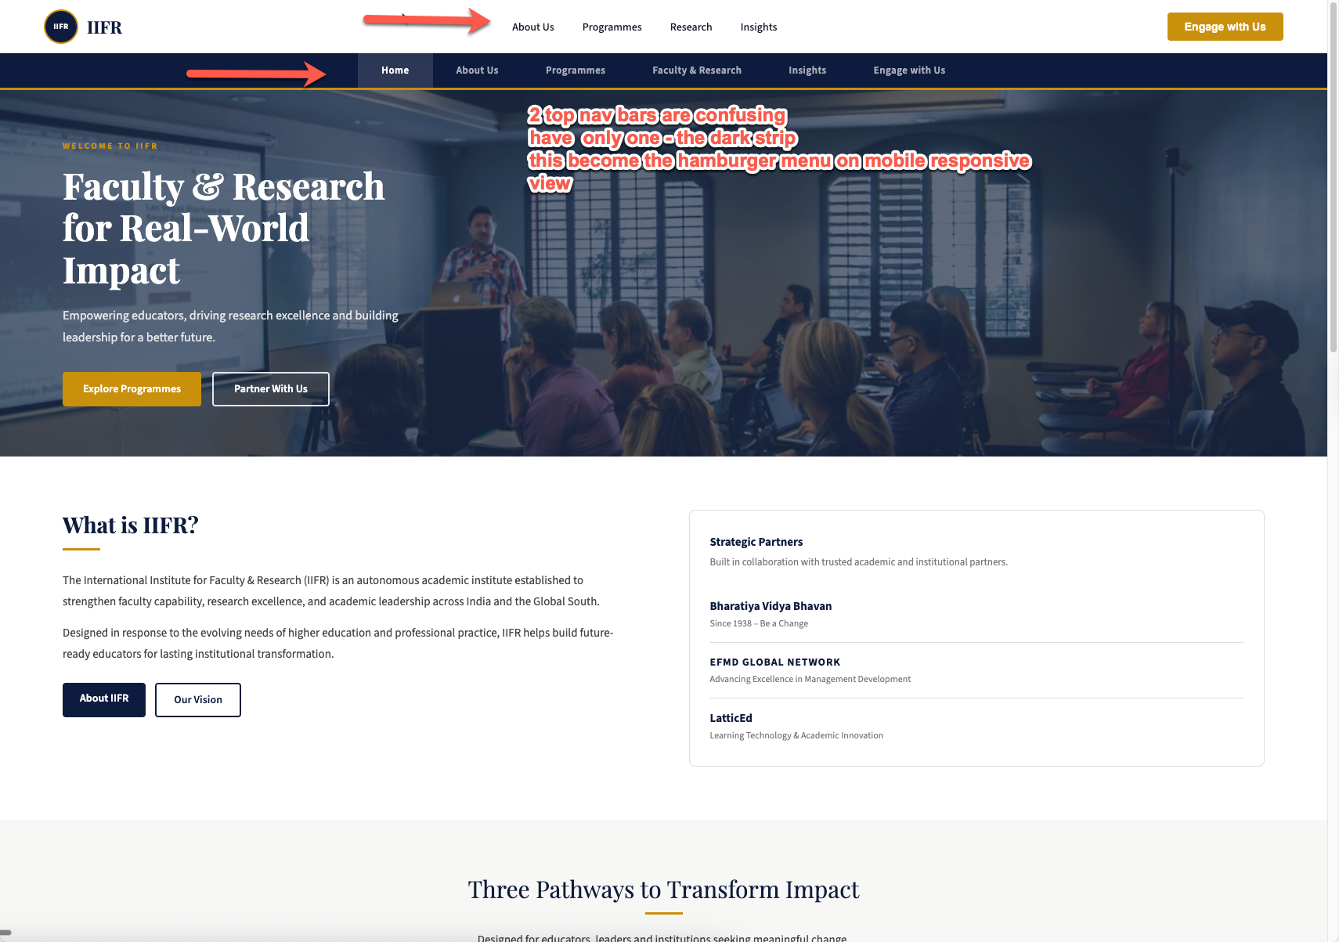

Home

Welcome to the International Institute of Faculty and Research (IIFR)
Building the Future of Faculty, Research, and Academic Leadership
Empowering educators, driving research excellence, nurturing pracademics and building great practice-academic synthesis
Explore Programs Partner With Us
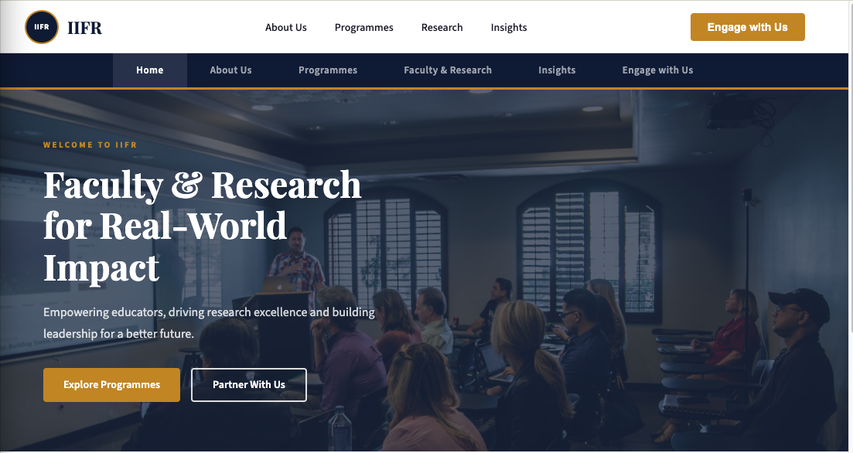

What is IIFR
The International Institute for Faculty & Research (IIFR) is an autonomous academic institute established to strengthen faculty capability, research excellence, and academic leadership across India and the Global South.
Designed for the evolving needs of higher education and professional practice, IIFR brings practitioners & academicians together and integrates relevance & rigor to support impactful pedagogy and applied research.
About IIFR: Our Vision
Strategic Partners:
Built in collaboration with trusted academic and institutional partners.
Bharatiya Vidya Bhavan
Since 1938 Shaping Education & Society
EFMD GLOBAL NETWORK
Advancing Excellence in Management Development
LatticEd
Pioneering Learning impact & Academic Innovation
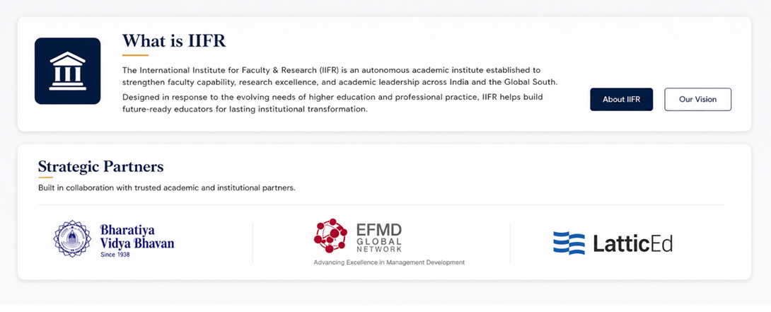Three Pathways to Transform Your Impact
Designed for leaders in academia, industry, and research seeking to create lasting influence.
01
Industry to Academia
For senior professionals and CXOs ready to move from the boardroom to the classroom lectern, without leaving their expertise at the door. The Pracademic credential enables you to teach, mentor, and lead at any management institution, with both practitioner authority and academic credibility.
02
Academic Faculty Excellence
For faculty who want the credential to match their experience and the framework to make their teaching create impact. Elevate pedagogy, research output, and global credibility with a recognized certification that opens doors.
03
Applied Research
For Senior executives, CXOs, and experts who want their years of experience to outlive them, converted into a scholarship that institutions cite, students read, and the world actually uses. Legacy-building for people who still have work to do.
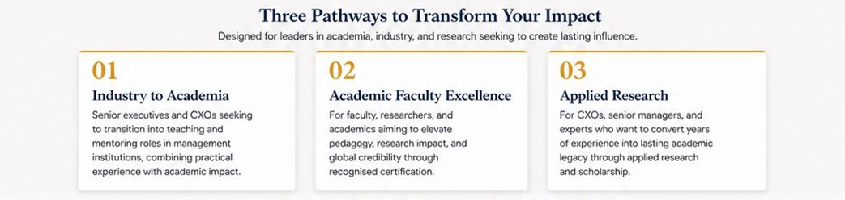

Programmes Designed for Academic and Professional Excellence
Practice-oriented learning experiences for educators, leaders, and researchers.
Educator Image
Educator Certification Programme (ECP)
For professionals and aspiring educators preparing for impactful academic careers, integrating theory & practice, AI-led pedagogy, and meta-frameworks for multi-disciplinary orientation.
→
Executive Image
Executive Fellow in Management (EFM)
For CXOs and senior leaders seeking to contribute via applied research, teaching through teaching, mentoring, and thought leadership.
→
Research Image
Research & Faculty Workshops
Short-format programmes focused on teaching excellence, research capability, and leadership development.
→
Explore All Programmes
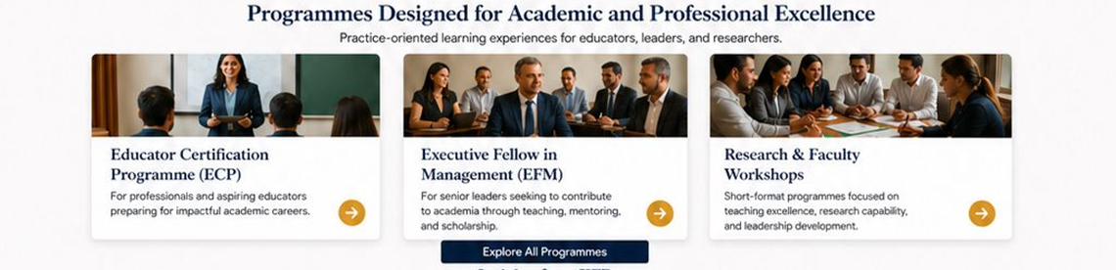

Insights from IIFR
Perspectives on higher education, faculty development, research, leadership, and professional practice.
May 15, 2026
Rethinking Faculty Development in India
Why continuous learning, mentoring, and capability building are essential for the future of higher education.
Read More →
April 28, 2026
Bridging Academia and Industry
Building meaningful partnerships to create relevant learning and real-world impact.
Read More →
April 10, 2026
The Future of Applied Research
How applied research can address real-world challenges and shape societal progress.
Read More →
View All Insights
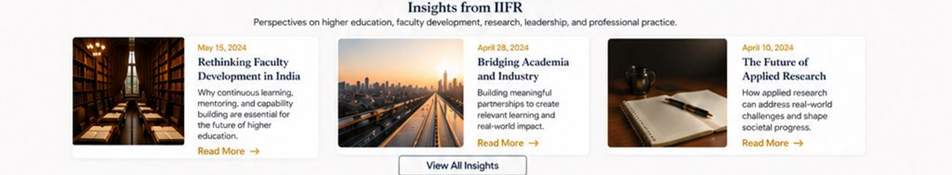

Let's Build the Future of Education, Together.
Partner, learn, collaborate, and lead transformation with IIFR.
Engage with Us
IIFR
IIFR
in
𝕏
▶
✉
Quick Links
- About Us
- Programmes
- Research
- Partnerships
- Insights
- Contact Us
Contact Us
📍 BVB Campus, Gate 4,
KG Marg, New Delhi
📞 +91 79 81895005
✉ info@iifr.global
Engage With Us
© 2026 International Institute for Faculty & Research. All Rights Reserved.
Privacy Policy Terms of Use Sitemap


ABOUT US

About Us
The International Institute for Faculty & Research advances higher education, research, and leadership across India and the Global South.

About IIFR
The International Institute of Faculty & Research (IIFR) is a multidisciplinary global institute integrating academic and industry perspectives to advance education and professional practice.
We bring together scholars, practitioners, and institutions to foster innovation in teaching, research, and leadership for a more connected and sustainable world.
Campus Image
Our Purpose
Higher education is evolving. IIFR was established to address critical gaps and create a future-ready ecosystem for faculty, research, and leadership development.
🎓
Bridge the gap between academia and industry.
💡
Advance innovation in research and practice.
👤
Develop leaders who can navigate complex global challenges.
🌐
Build a collaborative global network for impact and influence.
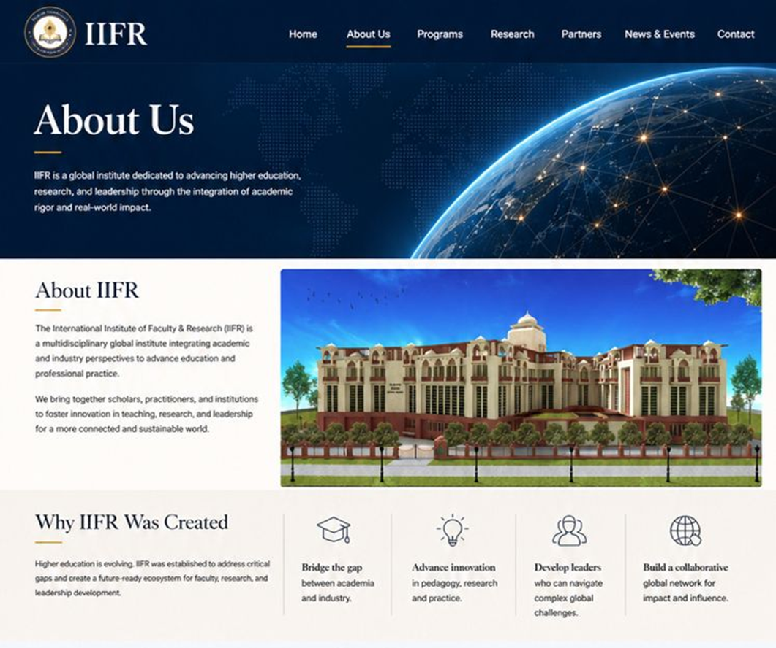

Our Vision
To be a multidisciplinary global institute integrating academic and industry perspectives to advance education and professional practice.
Our Mission
To realise our vision, IIFR is committed to four enduring priorities:
1
Cultivating Academic Leaders
Cultivating a new generation of faculty and academic leaders equipped to integrate theory & practice and drive pedagogical innovation and institutional transformation.
2
Advancing Applied Scholarship
Advancing interdisciplinary applied research that transcends boundaries to solve complex real-world challenges and shape global policy.
3
Developing Scholar-Practitioners
Developing pracademics - scholar-practitioners who navigate and influence the fluid intersection of classroom, boardroom, and government.
4
Building a Global Network
Building a high-impact global network that fosters seamless collaboration between the world's leading scholars and industry practitioners.
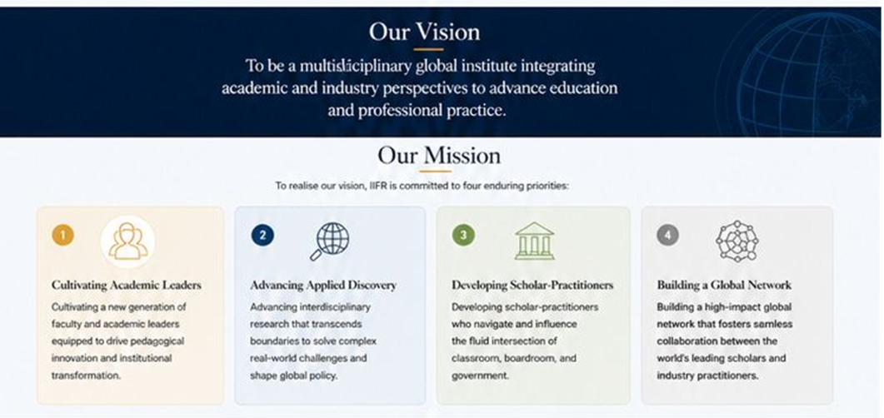

Leadership & Governance
Executive Board
The Executive Board provides strategic oversight, institutional stewardship, and long-term leadership to guide IIFR's growth, governance, and strategic priorities.
Leadership
👤
Banwarilal Purohit
Chairman, IIFR
👤
Rajendra Srivastava
Vice Chairman, IIFR
Members
👤
Rohit Bansal
👤
Siva Prasad
👤
Aruna Reddy
Academic Council
The Academic Council is central to IIFR's vision, offering strategic guidance on academic excellence, research priorities, and long-term institutional development.
👤
Rishikesh Krishnan
👤
Bhimaraya Metri
👤
Aravind Sahay
👤
Rajendra Srivastava
👤
Gerry George
👤
Nandu Nandakishore
👤
Howard Hunter
👤
Ashish Sinha
👤
Uday B Desai
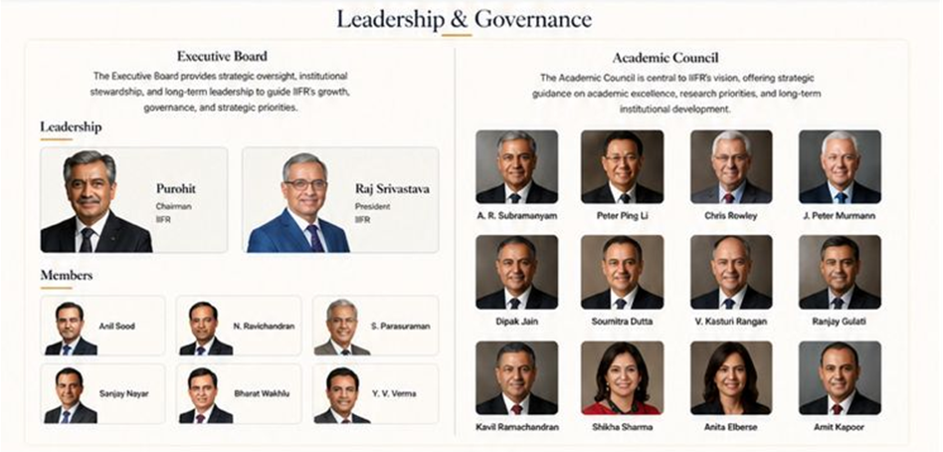
Strategic Partners
BVB
BVB is a premier Indian educational and cultural trust founded by Dr. K.M. Munshi with the support of Mahatma Gandhi
Learn more →
EFMD
EFMD is a global association fostering excellence in management development through accreditation, research, and collaboration.
Learn more →
LatticeEd
LatticeEd empowers institutions with innovative solutions for learning, research, and academic transformation.
Learn more →
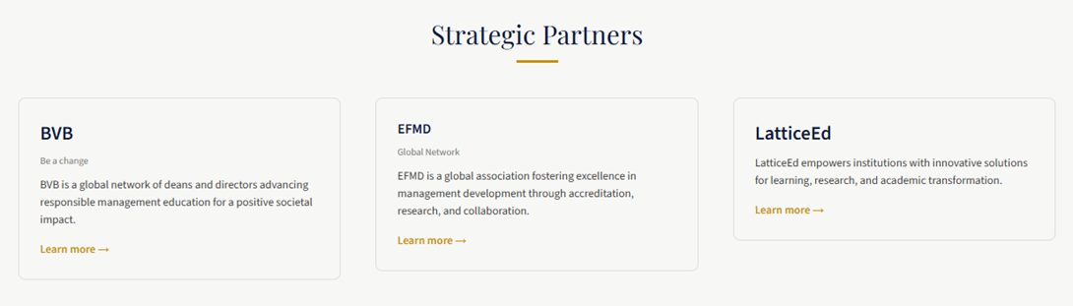

Let's Build the Future of Education, Together.
Partner, learn, collaborate, and lead transformation with IIFR.
Engage with Us
IIFR
IIFR
in
𝕏
▶
✉
Quick Links
- About Us
- Programmes
- Research
- Partnerships
- Insights
- Contact Us
Contact Us
📍 BVB Campus, Gate 4,
KG Marg, New Delhi
📞 +91 79 81895005
✉ info@iifr.global
Engage With Us
© 2026 International Institute for Faculty & Research. All Rights Reserved.Privacy Policy Terms of Use Sitemap


Programmes

Programmes for Real-World Impact
High-impact learning experiences designed for educators, researchers, L&D leaders, and senior industry professionals seeking meaningful impact.
Explore Programmes →Engage with Us
Our Programmes
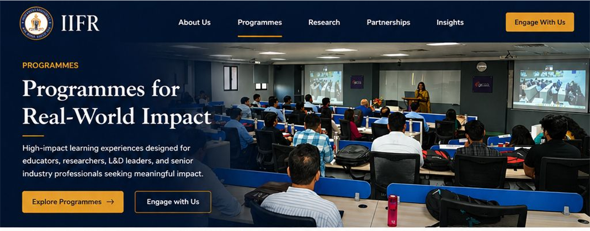
Educator

Educator Certification Programme (ECP)
Enhance pedagogy and teaching excellence, leveraging theory-practice synergies and AI.
View Details →
Executive

Executive Fellow in Management (EFM)
Translate senior experience into scholarship, teaching, and thought leadership.
View Details →
Academic

Custom Executive & Institutional Programmes
Tailored learning solutions for universities, institutions, and corporates.
View Details →
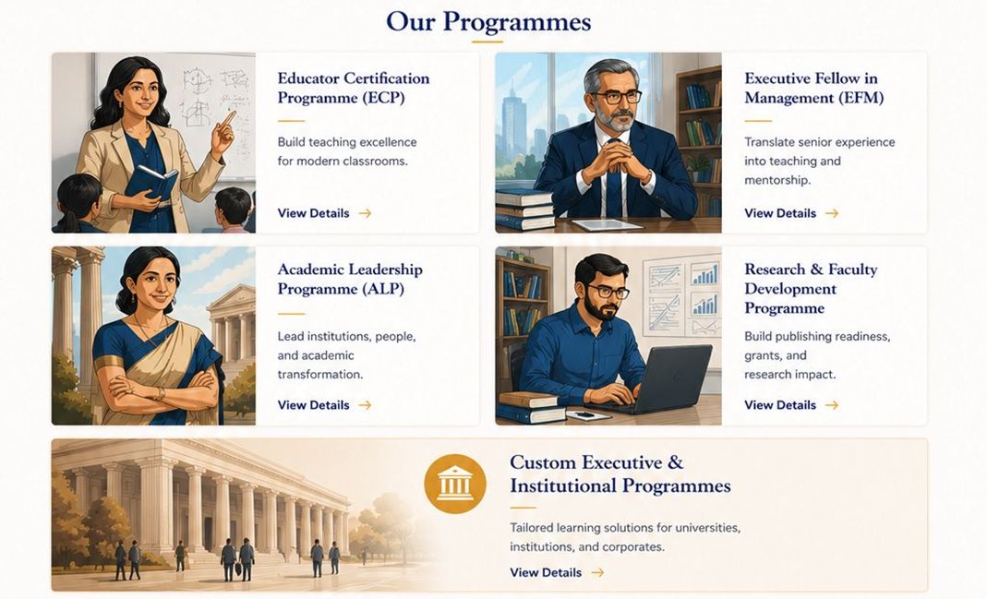


Why Choose IIFR Programmes
⚖️
Balancing Relevance & Rigour
Our programmes combine academic depth with practical applicability to create meaningful, real-world impact.
🧠
Fostering Multi-disciplinary Thinking
Gain integrated perspectives across strategy, marketing, finance, technology, leadership, and other functional domains to solve complex contemporary challenges.
📖
Enabling Industry-Academia-Policy Collaboration
Bridge the gap between what industry knows, what policy makers do, and what academia teaches through practice-based learning experiences.
🤝
Global Perspectives, Global South implications
International exposure with faculty from across India, the US, Europe, Asia, and Australia. Creating a channel for knowledge exchange and academic dialogue. .

Who These Programmes Are For
🎓
Educators & Faculty
Build teaching excellence, research capability, and academic influence.
👥
Academic Leaders
For deans, directors, HoDs, and institutional decision-makers.
🔬
Researchers & Scholars
Strengthen publishing readiness, grants, and applied research impact.
💼
Industry Leaders
Translate experience into teaching, capability-building, and institutional contribution.
L&D Professionals
🏛️
Institutions & Universities
Partner for customised faculty development and transformation programmes.
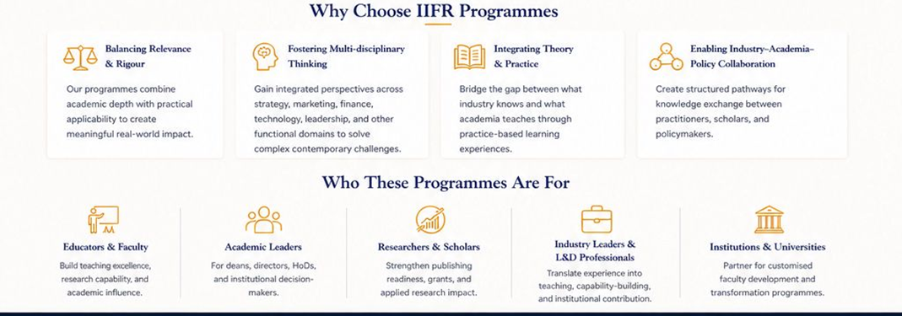

IIFR
IIFR
in
𝕏
▶
✉
Quick Links
- About Us
- Programmes
- Research
- Partnerships
- Insights
- Contact Us
Contact Us
📍 BVB Campus, Gate 4,
KG Marg, New Delhi
📞 +91 79 81895005
✉ info@iifr.global
Engage With Us
© 2026 International Institute for Faculty & Research. All Rights Reserved.
Privacy Policy Terms of Use Sitemap


Research

Faculty & Research for Real-World Impact
IIFR brings together global scholars, practice faculty, and research leaders solving challenges at the intersection of academia, industry, and policy.
Engage With Us Explore Programmes
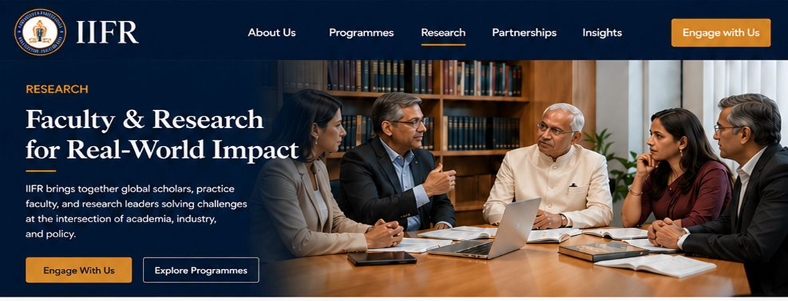
Our Faculty
A Diverse Faculty Ecosystem
IIFR’s faculty model blends globally connected academics, accomplished practice leaders, and scholar-practitioners who bring contemporary relevance into teaching, research, and institutional transformation.
Our faculty community includes internationally networked scholars, senior industry professionals, policy thinkers, and educators committed to pedagogical innovation.
View All Faculty Profiles →
Include all profiles from the current page: https://iifr.global/faculty.php
Read More →
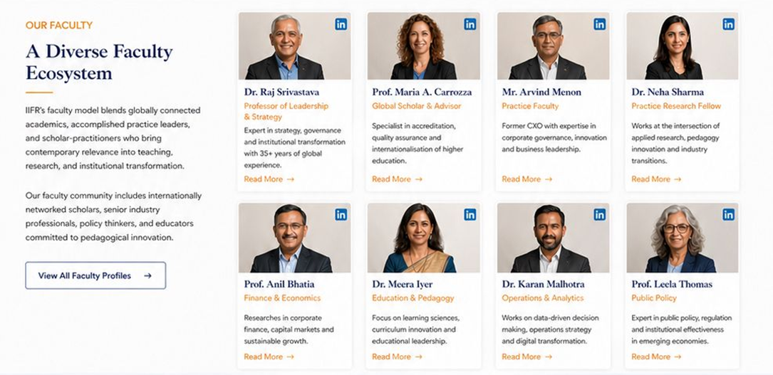

Research that Solves Real Problems
IIFR advances applied, interdisciplinary research shaped by contemporary organisational and societal challenges.
🤝
Industry–Academia Collaboration
Bridging theory and practice through co-created research, joint projects, and real-world solutions.
🏛️
Leadership & Governance
Research on board effectiveness, institutional excellence, ethical leadership, and organisational change.
🧠
Future of Work & Learning
Exploring talent, capability building, lifelong learning ecosystems, and the future of work.
📋
Public Policy & Institutions
Evidence-based research to inform policy, strengthen institutions, and advance national development.
Advancing Teaching Excellence Through Innovation
🤖
AI-Enabled Pedagogy
Our faculty pioneer new approaches to teaching through AI-enabled pedagogy, experiential learning, case-based instruction, and digitally enhanced academic delivery.
🌟
Transformative Learning Experiences
We design executive learning journeys, immersive classroom experiences, and practical learning formats that build capability and drive real impact.
🤝

Collaborate With IIFR
Partner with our faculty and research ecosystem to co-create knowledge, build capability, and make a meaningful impact.
Engage With Us, Know More About Programmes
📖 Research
Partner with IIFR to co-create applied research that solves organisational, educational, and policy challenges.
👥 Teaching
Engage with our faculty to design executive learning, pedagogy innovation, and capability-building initiatives.
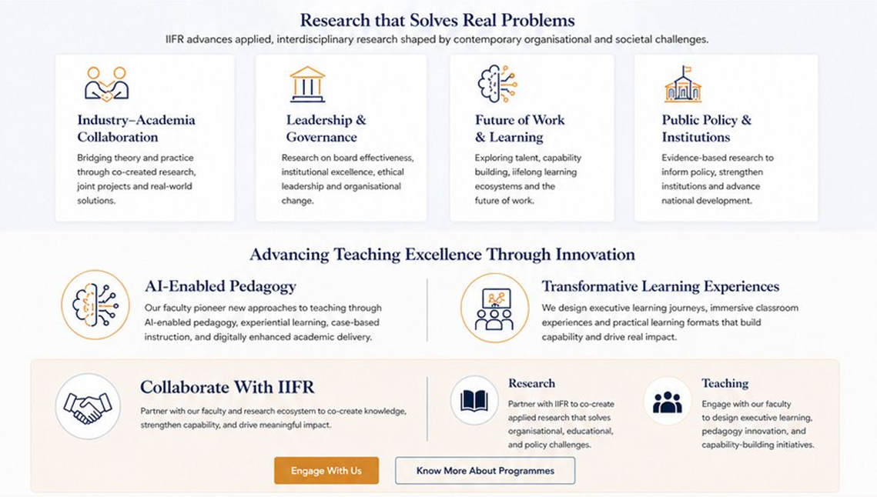
IIFR
IIFR
in
𝕏
▶
✉
Quick Links
- About Us
- Programmes
- Research
- Partnerships
- Insights
- Contact Us
Contact Us
📍 BVB Campus, Gate 4,
KG Marg, New Delhi
📞 +91 79 81895005
✉ info@iifr.global
Engage With Us

© 2026 International Institute for Faculty & Research. All Rights Reserved.
Privacy Policy Terms of Use Sitemap


Application form to capture:

- Full Name
- Email Address
- Phone Number (required — for WhatsApp follow-up)
- Organization / Institution (optional)
- Current Role (Executive / Faculty / Administration / Government / Others)
- How did you hear about us? (dropdown: Website / LinkedIn / Instagram / X / Facebook / Referral / Event / Other)
- Message / Query (optional free text)

